**Task 1.2 (SQL-Oracle)**

**Stage 1:**

* Construct and ER-Diagram for the above-mentioned requirement.

ER-Diagram-

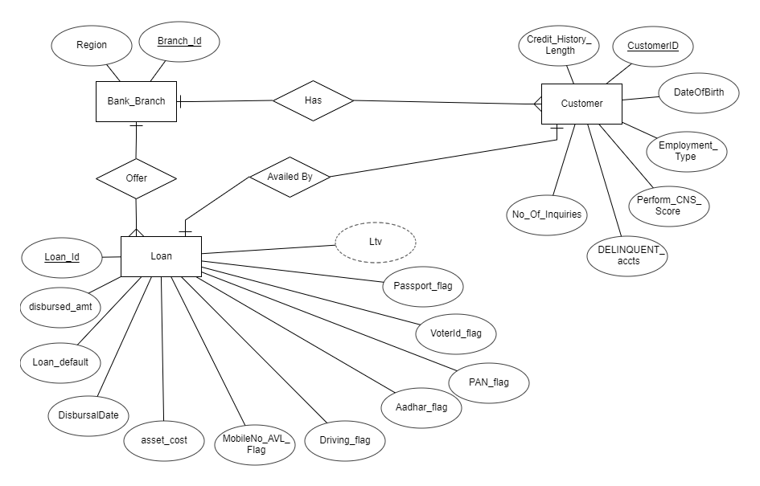

* Construct Tables has per the ER-Diagram.

1. Table Name - Bank_Branch

|  |  |
| --- | --- |
| Branch_id | Region |
|  |  |
|  |  |
|  |  |
|  |  |
|  |  |

Schema: Bank_Branch (Branch_id, Region)

1. Table Name – Customer

|  |  |  |  |  |  |  |
| --- | --- | --- | --- | --- | --- | --- |
| CustomerID | DateOfBirth | Employment_Type | Perform_CNS_Score | DELINQUENT_accts | Credit_History_Length | No_Of_Inquiries |
|  |  |  |  |  |  |  |
|  |  |  |  |  |  |  |
|  |  |  |  |  |  |  |
|  |  |  |  |  |  |  |
|  |  |  |  |  |  |  |
|  |  |  |  |  |  |  |
|  |  |  |  |  |  |  |

Schema: Customer(CustomerID, DateOfBirth, Employment_Type, Perform_CNS_Score, DELINQUENT_accts, Credit_History_Length, No_Of_Inquiries)

1. Table Name - Loan

|  |  |  |  |  |  |  |  |  |  |  |
| --- | --- | --- | --- | --- | --- | --- | --- | --- | --- | --- |
| Loan_Id | Loan_default | DisbursalDate | disbursed_amt | asset_cost | PAN_flag | MobileNo_AVL_Flag | Aadhar_flag | VoterId_flag | Driving_flag | Passport_flag |
|  |  |  |  |  |  |  |  |  |  |  |
|  |  |  |  |  |  |  |  |  |  |  |
|  |  |  |  |  |  |  |  |  |  |  |
|  |  |  |  |  |  |  |  |  |  |  |
|  |  |  |  |  |  |  |  |  |  |  |
|  |  |  |  |  |  |  |  |  |  |  |

Schema: Loan(Loan_Id, Loan_default, DisbursalDate, disbursed_amt, asset_cost, PAN_flag, MobileNo_AVL_Flag, Aadhar_flag, VoterId_flag, Driving_flag, Passport_flag)

* Identify the relationships between tables and use appropriate standards for the same where applicable.

Relational Schema-

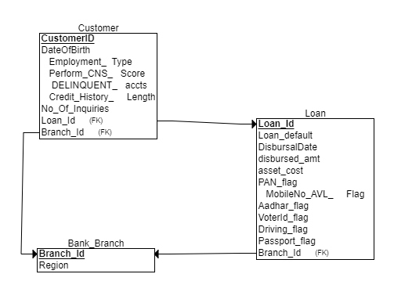

1. Relationship – Offer

Many Loan_id can have the same Branch_id so it is a many to one relationship.

Here, 2 tables will be required-

1. Loan-Offer(Branch_Id, Loan_Id, Loan_default, DisbursalDate, disbursed_amt, asset_cost, PAN_flag, MobileNo_AVL_Flag, Aadhar_flag, VoterId_flag, Driving_flag, Passport_flag)
2. Bank_Branch(Branch_id, Region)
3. Relationship – Has

Many CustomerID can have the same Branch_id so it is a many to one relationship.

Here, 2 tables will be required-

1. Customer-Has(Branch_Id, CustomerID, DateOfBirth, Employment_Type, Perform_CNS_Score, DELINQUENT_accts, Credit_History_Length, No_Of_Inquiries)
2. Bank_Branch(Branch_id, Region)
3. Relationship – Availed By

One CustomerID can avail only one loan_id so it is a one to one relationship.

Here, 2 tables will be required-

1. Loan-Availed By(CustomerID, Loan_Id, Loan_default, DisbursalDate, disbursed_amt, asset_cost, PAN_flag, MobileNo_AVL_Flag, Aadhar_flag, VoterId_flag, Driving_flag, Passport_flag)
2. Customer(CustomerID, DateOfBirth, Employment_Type, Perform_CNS_Score, DELINQUENT_accts, Credit_History_Length, No_Of_Inquiries)

* Insert the appropriate data into the identified tables from the sample dataset provided.

1. Inserting data into Bank_Branch Table-

INSERT INTO Bank_Branch VALUES(262, 'North-East');

SELECT * from Bank_Branch;

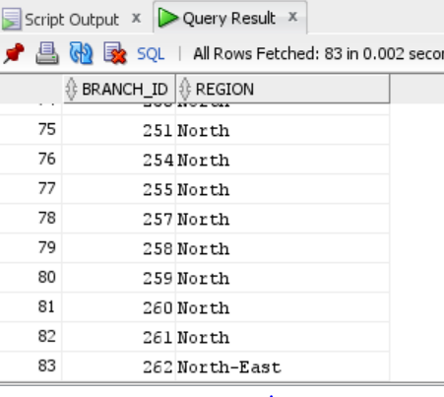

1. Inserting data into Customer Table-

INSERT INTO Customer VALUES('13-JUL-67','Self employed',1000,0,'0yrs 5mon',4,638,262,cust_id_seq.NEXTVAL);

SELECT * from Customer where perform_cns_score=1000;

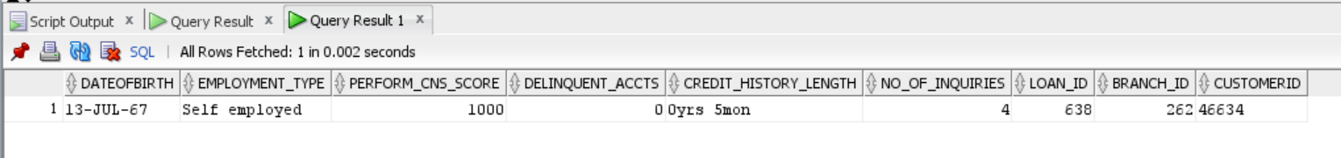

1. Inserting data into Loan Table-

INSERT INTO Loan VALUES(638,58376,64837,91.05,'13-SEP-18',1,1,0,0,0,0,1,262);

SELECT * from Loan where Loan_id=638 and Branch_id=262;



**Stage 2:**

*Assumption-Mandatory KYC documents for business loans are Aadhar card and PAN card (Mobile number already linked with Aadhar card) but due to no such records found with respect to the given queries, it has been assumed that mobile number is mandatory KYC document along with any one of the other five documents.*

*Since the primary key for customer table is not given so we have generated a sequence to uniquely identify the customers. The query for the same is given below-*

ALTER TABLE CUSTOMER ADD CustomerId VARCHAR(10);

CREATE SEQUENCE cust_id_seq START WITH 2

INCREMENT BY 2

MAXVALUE 99999999

MINVALUE 1

NOCYCLE;

UPDATE CUSTOMER SET CustomerId = cust_id_seq.NEXTVAL;

SELECT * FROM CUSTOMER;

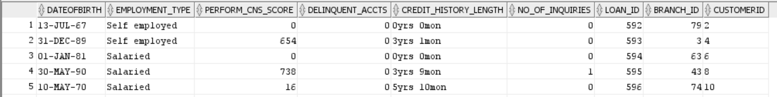

*This query adds a column CustomerId with unique values to the existing data to identify the customers.*

**Query 1-**

* Generate Reports of the customer who has approached for the loan and all KYC is submitted and disbursal date is not given, or loan is not disbursed.

*Case 1- If all KYC documents are submitted i.e., all 6 flags=1*

SELECT c.CUSTOMERID, c.DATEOFBIRTH, c.EMPLOYMENT_TYPE, c.PERFORM_CNS_SCORE, c.DELINQUENT_ACCTS, c.CREDIT_HISTORY_LENGTH, c.NO_OF_INQUIRIES

FROM Customer c

JOIN Loan l

ON c.Loan_id=l.Loan_id

WHERE (l.mobileno_avl_flag = 1

AND l.aadhar_flag = 1

AND l.pan_flag = 1

AND l.voterid_flag = 1

AND l.driving_flag = 1

AND l.passport_flag = 1

AND (l.disbursaldate IS NULL OR l.disbursed_amt = 0));

*Output-*

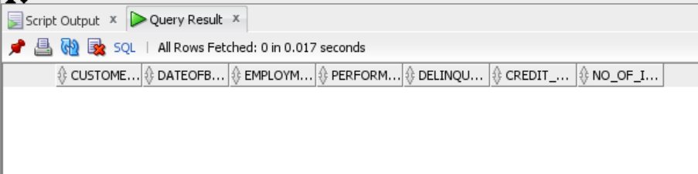

*Conclusion- As per the above output, it can be concluded that there are no such customers who have submitted all the KYC documents. So, we consider case 2.*

*Case 2- If mobile number is submitted along with any one of the other five documents.*

SELECT c.CUSTOMERID, c.DATEOFBIRTH, c.EMPLOYMENT_TYPE, c.PERFORM_CNS_SCORE, c.DELINQUENT_ACCTS, c.CREDIT_HISTORY_LENGTH, c.NO_OF_INQUIRIES

FROM Customer c

JOIN Loan l

ON c.Loan_id=l.Loan_id

WHERE (l.mobileno_avl_flag = 1

AND (l.aadhar_flag = 1

OR l.pan_flag = 1

OR l.voterid_flag = 1

OR l.driving_flag = 1

OR l.passport_flag = 1)

AND (l.disbursaldate IS NULL OR l.disbursed_amt = 0));

*Output-*



*Conclusion- As per the above output, it can be concluded that there are no such customers for whom the disbursal date is not given, or the loan is not disbursed. Since, the disbursal date and disbursed amount is present for all records, the loan is disbursed for all customers.*

**Query 2-**

* Generate Reports of the customer who has approached for the loan whose Bureau Score is less than 650 and min. inquires made is >3 and the cost of asset is between 50000 to 70000 and LTV is between the range of 50-60.

SELECT c.CUSTOMERID, c.DATEOFBIRTH, c.EMPLOYMENT_TYPE, c.PERFORM_CNS_SCORE, c.DELINQUENT_ACCTS, c.CREDIT_HISTORY_LENGTH, c.NO_OF_INQUIRIES

FROM Customer c

JOIN Loan l

ON c.Loan_id=l.Loan_id

WHERE c.perform_cns_score < 650

AND c.no_of_inquiries > 3

AND (l.asset_cost BETWEEN 50000 AND 70000)

AND (l.ltv BETWEEN 50 AND 60);

*Output-*

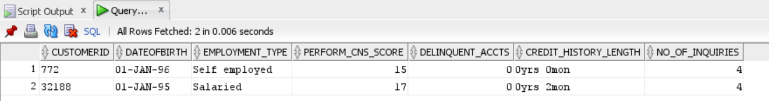

*Conclusion- From the above result, it can be concluded that there are 2 customers who satisfy the aforesaid conditions. Bureau scores less than 650 is considered as average.*

**Query 3-**

* Generate Reports of the customer who has approached for the loan whose Bureau Score is less than 650 and min. enquires made is >3 and the cost of asset is between 50000 to 70000 and LTV is between the range of 50-60.

*Same as query 2*

**Query 4-**

* Generate Reports of the self-employed customer who has approached for the loan whose Bureau Score is less than 650 and min. enquires made is >3 and loan default are 0 and if all KYC is submitted and cross checked if any dues to previous loans.

*Case 1- If all KYC documents are submitted i.e., all 6 flags=1*

SELECT c.CUSTOMERID, c.DATEOFBIRTH, c.EMPLOYMENT_TYPE, c.PERFORM_CNS_SCORE, c.DELINQUENT_ACCTS, c.CREDIT_HISTORY_LENGTH, c.NO_OF_INQUIRIES

FROM Customer c

JOIN Loan l

ON c.Loan_id=l.Loan_id

WHERE (c.employment_type = 'Self employed'

AND c.perform_cns_score < 650

AND c.no_of_inquiries > 3

AND l.loan_default = 0

AND l.mobileno_avl_flag = 1

AND l.aadhar_flag = 1

AND l.pan_flag = 1

AND l.voterid_flag = 1

AND l.driving_flag = 1

AND l.passport_flag = 1

AND c.delinquent_accts=0);

*Output-*

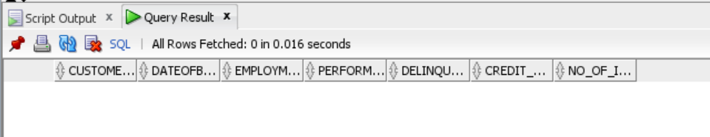

*Conclusion- As per the above output, it can be concluded that there are no such customers who have submitted all the KYC documents. So, we consider case 2.*

*Case 2- If mobile number is submitted along with any one of the other five documents.*

SELECT c.CUSTOMERID, c.DATEOFBIRTH, c.EMPLOYMENT_TYPE, c.PERFORM_CNS_SCORE, c.DELINQUENT_ACCTS, c.CREDIT_HISTORY_LENGTH, c.NO_OF_INQUIRIES

FROM Customer c

JOIN Loan l

ON c.Loan_id=l.Loan_id

WHERE (c.employment_type = 'Self employed'

AND c.perform_cns_score < 650

AND c.no_of_inquiries > 3

AND l.loan_default = 0

AND l.mobileno_avl_flag = 1

AND (l.aadhar_flag = 1

OR l.pan_flag = 1

OR l.voterid_flag = 1

OR l.driving_flag = 1

OR l.passport_flag = 1)

AND c.delinquent_accts=0);

*Output-*

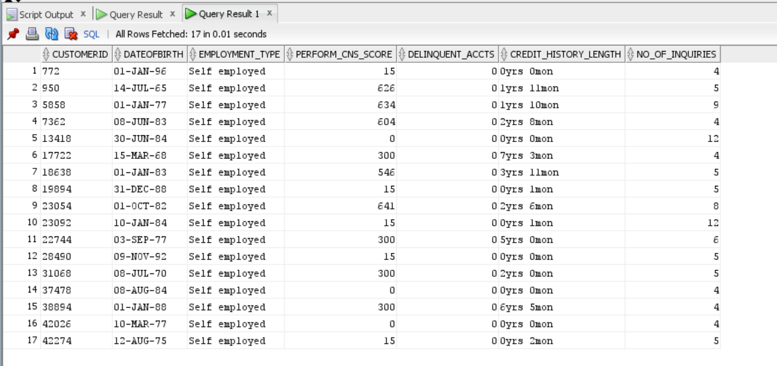

*Conclusion- From the above query result, it can be deduced that there are 17 such customers who have submitted the mobile number and Aadhar card as KYC documents and fulfil all the other mentioned constraints. These customers are non-defaulters since their loan default=0 and they don’t have any dues to the previous loans also with delinquent accounts=0 .*

**Query 5-**

* Generate Reports of those customers where the loan is disbursed based on the Cibil score ranging between 670 -780 and also who are acquired the loan for more than 1 time and loan default is 1 or 0.

SELECT c.CUSTOMERID, c.DATEOFBIRTH, c.EMPLOYMENT_TYPE, c.PERFORM_CNS_SCORE, c.DELINQUENT_ACCTS, c.CREDIT_HISTORY_LENGTH, c.NO_OF_INQUIRIES

FROM Customer c

JOIN Loan l

ON c.Loan_id=l.Loan_id

WHERE ((l.disbursed_amt>0 OR l.disbursaldate IS NOT NULL)

AND (c.perform_cns_score BETWEEN 670 and 780)

AND c.delinquent_accts>0

AND l.loan_default IN (0, 1));

*Output-*

An Excel file with name as ‘Query_5_output.xml’ is attached to the file folders.

*Conclusion- The above query returns 265 records which meet the above stated requirements. Cibil score in the range of 670-780 is considered good for the approval of loans. The output includes the defaulters as well as non-defaulters.*